**WEB DEVELOPMENT (INTRODUCTION)**

**WEDE5020**

**PROPOSAL 2**

**NESTA VAVEKI**

**ST10484597**

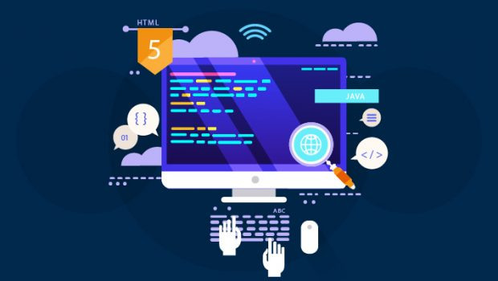

**TABLE OF CONTENTS**

TARGET ORGANISATION 3

ORGANISATION OVERVIEW 3

WEBSITE GOALS AND OBJECTIVES 4

CURRENT WEBSITE ANALYSIS 5

PROPOSED WEBSITE FEATURES AND FUNCTIONALITY 6

DESIGN AND USER EXPERIENCE 8

TECHNICAL REQUIREMENTS 10

TIMESLINES AND MILESTONES 11

BUDGET 12

REFERENCES 13

# TARGET ORGANISATION

Small Business

The main objective of this proposal is to accurately plan and execute the development of a functioning website for small business.

# ORGANISATION OVERVIEW

**Name:** *Harvest & Hearth Café*

**Year Established:** 2021  
**Location:** Florida Road, Durban, South Africa

**History:**  
Harvest & Hearth Café was founded during one of the toughest times for the hospitality industry — the COVID-19 pandemic. Childhood friends Lindiwe Mthethwa and Michael Harris, both passionate about food and community, decided to take a leap of faith. They converted a small, unused corner shop into a cozy café that felt like a living room, where every customer was treated like family.

Their vision was simple: serve fresh, wholesome meals made with local ingredients, while building a space where people could connect, slow down, and feel at home. They partnered with nearby farmers and suppliers to ensure that every ingredient was seasonal and ethically sourced. This approach didn’t just create incredible food — it also helped support small-scale agriculture in KwaZulu-Natal.

Within a year, Harvest & Hearth had become more than a café. It was a gathering place for food lovers, creatives, and entrepreneurs. They began hosting **“Meet-the-Farmer” brunches**, **supper clubs with live music**, and **cooking workshops** for locals wanting to learn farm-to-table cooking. Their environmentally conscious approach, from biodegradable packaging to composting food waste, earned them recognition as one of Durban’s most sustainable eateries.

**Mission Statement:**  
"To serve fresh, sustainable, and locally sourced meals while fostering community connections and supporting local farmers."

**Vision Statement:**  
"To be a leading example of sustainable dining in South Africa, where good food and community come together."

**Core Offerings:**

1. **Farm-to-Table Dining** – Menus change with the seasons, based on what local farmers harvest.
2. **Community Events** – Food markets, book club mornings, and cooking classes.
3. **Sustainability Practices** – Eco-friendly packaging, food waste composting, and reduced plastic use.
4. **Private Venue Hire** – Cozy space for small celebrations and business gatherings.

**Target Audience:**

* Health-conscious individuals aged 20–45
* Eco-conscious consumers and sustainability advocates
* Tourists seeking authentic local food experiences
* Local event organizers looking for intimate, unique venues

# WEBSITE GOALS AND OBJECTIVES

**Purpose of the Website**  
The Harvest & Hearth Café website should attract more people to visit in person, encourage bookings for tables and events, and communicate the café’s focus on sustainable dining and community connection.

**Specific Goals**

1. **Increase Visits to the Café**
   1. Highlight the café’s location with a clear map and directions.
   2. Display daily specials and seasonal dishes right on the homepage.
2. **Boost Table and Event Bookings**
   1. Set up a simple online booking tool.
   2. Offer special discounts for bookings made directly through the website.
3. **Show the Brand’s Story and Values**
   1. Use high-quality photos and write-ups to tell the story of the café’s farm-to-table approach.
   2. Introduce the local farmers and suppliers involved.
4. **Fill More Event Seats**
   1. Keep an easy-to-read calendar of upcoming cooking classes, music nights, and themed dinners.
   2. Allow tickets for these events to be purchased directly from the site.
5. **Connect the Website with Social Media**
   1. Embed Instagram and Facebook feeds to keep the site looking fresh.
   2. Add sharing buttons so visitors can post menu items and events to their own pages.

**Key Performance Indicators (KPIs)**

* Monthly website visits: 3,000 or more in the first year.
* Table/event bookings: At least 100 per month via the site.
* Event ticket sales: 80% of capacity sold through the site.
* Average time on site: Over 2 minutes per visitor.
* Social media click-throughs: At least 20% of visitors move from the site to Instagram or Facebook.
* Returning visitors: Maintain a return rate of 40% or higher.

# CURRENT WEBSITE ANALYSIS

**Strengths:**

1. **Strong Branding:** The café’s story, sustainability focus, and farm-to-table concept are clearly communicated.
2. **Menu Display:** Menu is visible and easy to read, making it simple for visitors to see offerings.
3. **Event Promotion:** Upcoming events are displayed, encouraging attendance and bookings.
4. **Online Booking Functionality:** Visitors can reserve tables or buy event tickets online.

**Weaknesses:**

1. **Limited Mobile Optimization:** The booking system may not work seamlessly on smaller screens.
2. **Visual Content Could Be Better:** Food photography may not fully capture the café’s aesthetic and vibe.
3. **Social Media Integration:** Links to Instagram and Facebook may not be prominently placed, reducing engagement.
4. **No Customer Interaction Features:** Lacks online reviews, feedback forms, or loyalty programs.
5. **Slow Load Times on Event Pages:** Pages with high-resolution photos or embedded videos may take longer to load.

**Areas for Improvement:**

* Fully optimize the booking system for mobile devices.
* Invest in professional photography and video content to showcase the café’s atmosphere and dishes.
* Add social media feeds on the homepage for better engagement.
* Include a feedback form or customer review section to encourage interaction and build trust.
* Compress media files or use lazy loading to improve page load times.

# PROPOSED WEBSITE FEATURES AND FUNCTIONALITY

**Homepage**

* Introduces the café’s story, philosophy, and sustainability focus.
* Highlights daily specials, promotions, and events.
* Buttons for booking tables or registering for events.
* **Function:** Attracts visitors immediately and guides them to key actions.

**About Us Page**

* Shares the founders’ story and café’s vision.
* Explains the farm-to-table approach and support for local farmers.
* **Function:** Builds a connection with customers and showcases the brand’s values.

**Menu Page**

* Displays food and drink options, seasonal items, and chef’s specials.
* Option to download the menu.
* **Function:** Lets customers see what’s available before visiting.

**Events Page**

* Shows calendar of upcoming cooking classes, live music nights, and other events.
* Provides online ticketing or RSVP forms.
* Includes images or videos from past events.
* **Function:** Promotes events and encourages attendance.

**Booking Page**

* Online reservation form for tables and private events.
* Shows available time slots and confirmation options.
* **Function:** Makes booking easy and convenient for customers.

**Gallery Page**

* Photo and video showcase of dishes, café interior, events, and customer experiences.
* Option to filter by category (food, events, behind-the-scenes).
* **Function:** Gives visitors a visual sense of the café’s vibe and atmosphere.

**Contact Page**

* Location map, phone number, email, and social media links.
* Contact form for inquiries or feedback.
* **Function:** Helps customers reach out easily.

**Social Media Integration**

* Embedded Instagram and Facebook feeds.
* Sharing buttons on menu items and events.
* **Function:** Encourages visitors to follow the café online and engage with content.

DESIGN AND USER EXPERIENCE

Colour Scheme

* **Primary Colours:** Earthy green (#6B8E23) – represents freshness and sustainability.
* **Secondary Colours:** Warm brown (#8B4513) – reflects coffee and hearth warmth.
* **Accent Colours:** Cream (#FFF5E1) – for backgrounds and highlights.
* **Usage:** Green for headings/buttons, brown for text accents, cream for neutral backgrounds.

Typography

* **Heading Font:** Lora Bold – elegant, slightly rustic feel for headings.
* **Body Font:** Roboto Regular – clean and readable for menus and event details.
* **Hierarchy:**
  + H1: Homepage main title
  + H2: Menu sections, events, gallery headings
  + H3/H4: Item names, descriptions, dates

Layout and Design Approach

* **Overall Design:** Warm, inviting, and slightly rustic. Emphasizes café atmosphere.
* **Page Structure:**
  + Homepage: Hero banner with featured dishes/events, quick menu overview.
  + Menu Page: Grid or list layout with images, prices, and descriptions.
  + Booking & Events Pages: Simple forms, calendar integration.
* **Design Elements:** Rounded cards for menu items, soft shadows, hover effects for buttons.

User Experience Considerations

* **Navigation:** Top sticky menu with logo, pages (Home, Menu, Events, Booking, Gallery, Contact).
* **Layout:** Focus on clarity—menu items and booking buttons are easy to find.
* **Accessibility:** High contrast between text and background, mobile-first design.
* **Colour Scheme:** Green evokes freshness, brown for warm accents, cream backgrounds for readability.

Low-Fidelity Wireframe Description

**Homepage:**

* Top: Logo and menu navigation.
* Hero section: Large café image with tagline.
* Featured menu items/events: 3–4 cards with images and CTA buttons (Order/Book).
* Footer: Contact info, location map, social media.

**Menu Page:**

* Grid layout with item images, names, descriptions, and prices.
* Optional filter by category (Breakfast, Lunch, Drinks).

**Booking Page:**

* Simple form: Name, date/time, number of guests.
* “Submit” button with confirmation message.

**Gallery Page:**

* Grid of images showcasing dishes, events, and café ambience.

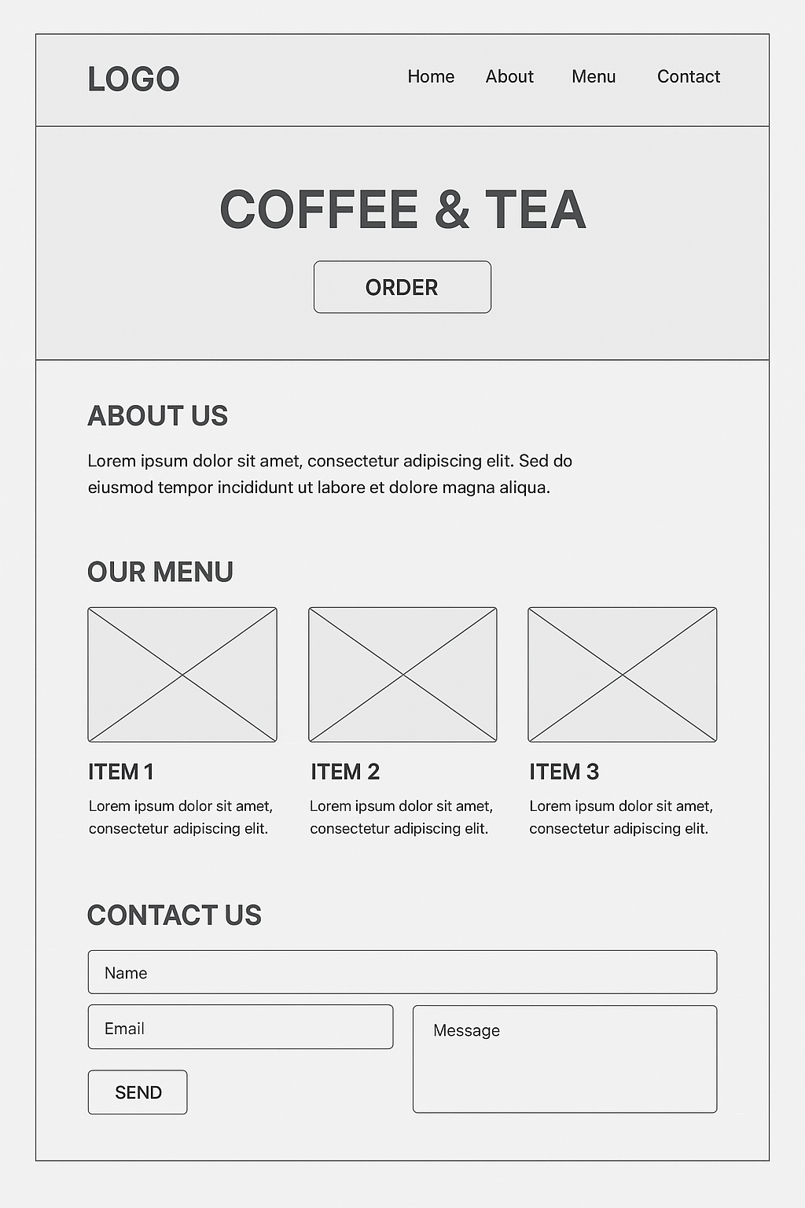

# TECHNICAL REQUIREMENTS

Hosting and Domain Requirements

* **Domain Name:** harvestandhearth.co.za (or something that reflects the café’s brand).
* **Hosting Needs:**
  + Shared or cloud hosting to handle e-commerce features and medium traffic.
  + At least 5GB storage and 100GB monthly bandwidth.
  + SSL certificate to secure online payments.
  + Daily backups and 99% uptime.
* **Email:** [hello@harvestandhearth.co.za](mailto:hello@harvestandhearth.co.za) for customer inquiries and bookings.

Programming Languages and Frameworks

* **Frontend:** HTML5, CSS3, and JavaScript for interactive menus and event pages.
* **Backend:** PHP or Node.js for processing bookings, orders, and event registrations.
* **CMS/E-commerce Platform:** WordPress with WooCommerce or Shopify.
* **Database:** MySQL or Firebase for storing orders, customer details, and event information.
* **Additional Tools:** Online booking plugins, menu/event management plugins, and SEO/analytics tools.

# TIMESLINES AND MILESTONES

|  |  |  |
| --- | --- | --- |
| **Week** | **Task** | **Notes** |
| 1 | Plan the website | Define features, KPIs, and pages needed. |
| 2–3 | Wireframes & sitemap | Homepage, menu, booking, events, gallery pages. |
| 4–5 | Frontend development | Build responsive pages with HTML, CSS, JavaScript. |
| 6 | Backend & e-commerce setup | Install WooCommerce or Shopify, integrate payments. |
| 7 | Add content | Menu items, event details, images, and descriptions. |
| 8 | Test functionality | Check online booking, payments, and responsiveness. |
| 9 | SEO & Analytics | Optimize pages for search engines, set up tracking. |
| 10 | Review site | Check user experience, fix bugs or slow-loading pages. |
| 11 | Final adjustments | Compress images, finalize content, check all links. |
| 12 | Launch & submit | Make website live and submit for assessment. |

# BUDGET

Harvest & Hearth Café – Website Budget Estimate

Website Development Costs

|  |  |  |
| --- | --- | --- |
| **Item** | **Estimated Cost (ZAR)** | **Description** |
| **Custom Website Design** | R20,000 – R30,000 | Design reflecting the café's brand and ambiance. |
| **E-commerce Integration** | R10,000 – R15,000 | Online ordering and payment system setup. |
| **Content Management System (CMS)** | R5,000 – R10,000 | User-friendly CMS for menu and content updates. |
| **SEO Optimization** | R3,000 – R6,000 | Enhancing search engine visibility. |
| **Responsive Design** | Included | Mobile and tablet-friendly layout. |
| **Total Development Cost** | **R38,000 – R61,000** | Comprehensive development package. |

Domain Registration & Hosting

|  |  |  |
| --- | --- | --- |
| **Item** | **Estimated Cost (ZAR)** | **Description** |
| **Domain Registration (.co.za)** | R107.33/year | Annual registration fee. |
| **Web Hosting** | R200 – R500/month | Hosting suitable for e-commerce sites. |
| **Total Annual Hosting** | **R2,400 – R6,000** | Yearly hosting cost. |

Website Maintenance Costs

|  |  |  |
| --- | --- | --- |
| **Item** | **Estimated Cost (ZAR)** | **Description** |
| **Monthly Maintenance** | R1,000 – R3,000/month | Regular updates, backups, and security checks. |
| **Total Annual Maintenance** | **R12,000 – R36,000** | Yearly maintenance cost. |

Total Estimated Annual Budget for Harvest & Hearth Café

|  |  |
| --- | --- |
| **Category** | **Estimated Cost (ZAR)** |
| **Development** | R38,000 – R61,000 |
| **Hosting** | R2,400 – R6,000 |
| **Maintenance** | R12,000 – R36,000 |
| **Total** | **R52,400 – R103,000** |

# REFERENCES

1. Allanux Web. (2025). *Average Website Maintenance Costs in South Africa*. Available at: <https://www.allanuxweb.com/blog/website-maintenance-costs>
2. Bunnypants. (2025). *How much does web design cost in South Africa? 2025 - 2026 Guide*. Available at: <https://www.bunnypants.co.za/how-much-does-web-design-cost-in-south-africa/>
3. HostAfrica. (2025). *How much is it to host a website?* Available at: <https://www.hostafrica.com/blog/hosting/how-much-is-it-to-host-a-website/>
4. Qadra Studio. (2025). *Web Design Pricing South Africa*. Available at: <https://qadra.studio/pricing/web-design-pricing-south-africa/>
5. Shopify. (2025). *How much does a website cost in 2025? A Complete Guide*. Available at: <https://www.shopify.com/za/blog/how-much-does-a-website-cost>
6. Truehost. (2025). *Guide To Cost Of Hosting A Website In South Africa (Table)*. Available at: <https://truehost.co.za/cost-of-hosting-website-south-africa/>
7. Webluno. (2025). *Cost Of Website Maintenance Services in South Africa*. Available at: <https://webluno.co.za/cost-of-website-maintenance/>
8. Xneelo. (2025). *Trusted in Hosting*. Available at: <https://xneelo.co.za/>